1. [Write a C program to print all natural numbers from 1 to n.](https://codeforwin.org/2015/06/c-program-to-print-natural-numbers-from-1-to-n.html)
2. [Write a C program to print all natural numbers in reverse (from n to 1)](https://codeforwin.org/2015/07/c-program-to-print-all-natural-numbers-in-reverse.html). –
3. [Write a C program to print all alphabets from a to z.](https://codeforwin.org/2015/06/c-program-to-print-a-to-z.html)
4. [Write a C program to print all even numbers between 1 to 100.](https://codeforwin.org/2015/06/c-program-to-print-all-even-numbers-between-1-to-100.html)
5. [Write a C program to print all odd number between 1 to 100.](https://codeforwin.org/2015/06/c-program-to-print-all-odd--numbers-between-1-to-100.html)
6. [Write a C program to find sum of all natural numbers between 1 to n.](https://codeforwin.org/2015/06/c-program-to-calculate-sum-of-first-n-natural-numbers.html)
7. [Write a C program to find sum of all even numbers between 1 to n](https://codeforwin.org/2015/06/c-program-to-print-sum-of-all-even-numbers-between-1-to-n.html).
8. [Write a C program to find sum of all odd numbers between 1 to n](https://codeforwin.org/2015/06/c-program-to-print-sum-of-all-odd-numbers-between-1-to-n.html).
9. [Write a C program to print multiplication table of any number](https://codeforwin.org/2015/06/c-program-to-print-table-of-any-number.html).
10. [Write a C program to count number of digits in a number](https://codeforwin.org/2016/10/c-program-to-count-number-of-digits-in-number.html).
11. [Write a C program to find first and last digit of a number](https://codeforwin.org/2015/06/how-to-find-first-and-last-digit-of-any-number.html).
12. **CODE-**

#include <stdio.h>

int main()

{ int i, n ;

printf("enter the no. upto which natural numbers should be printed : ") ;

scanf("%d",&n) ;

for(i=1;i<=n;i++)

printf("%d \n", i) ;

return 0;

}

**OUTPUT-**

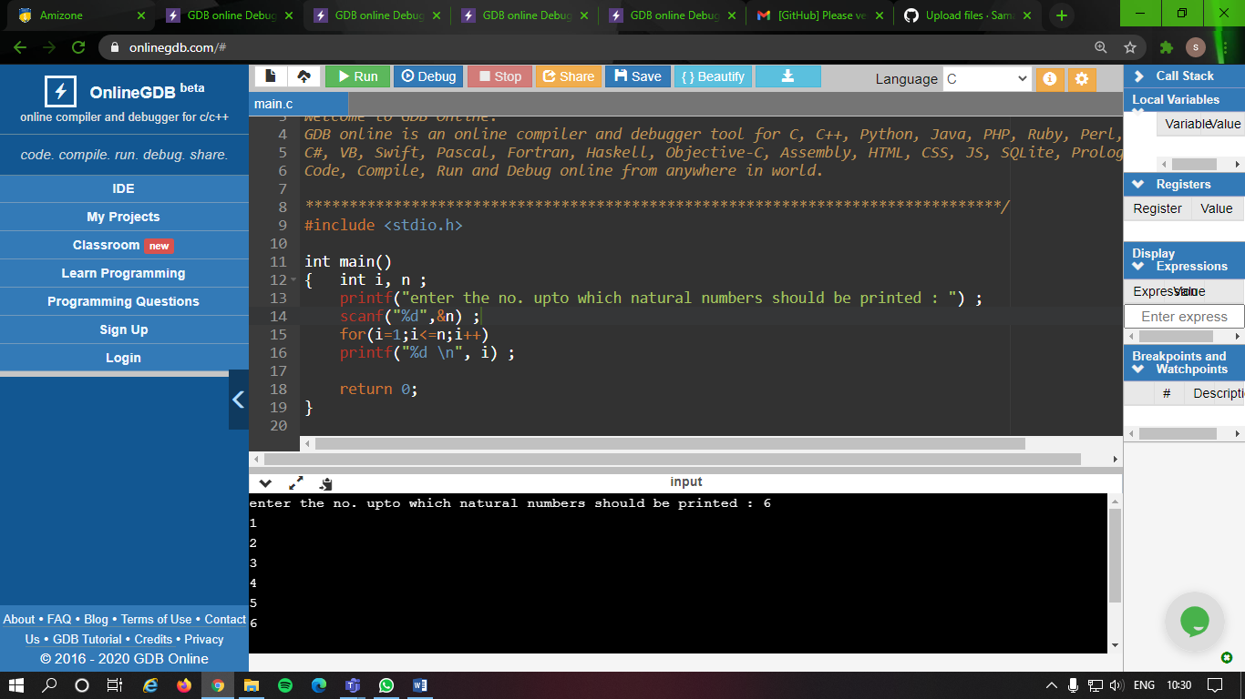

1. **CODE-**

#include <stdio.h>

int main()

{ int i, n ;

printf("enter the no. from which natural numbers should be printed in reverse : ") ;

scanf("%d",&n) ;

for(i=n;i>=1;i--)

printf("%d \n", i) ;

return 0;

}

**OUTPUT-**

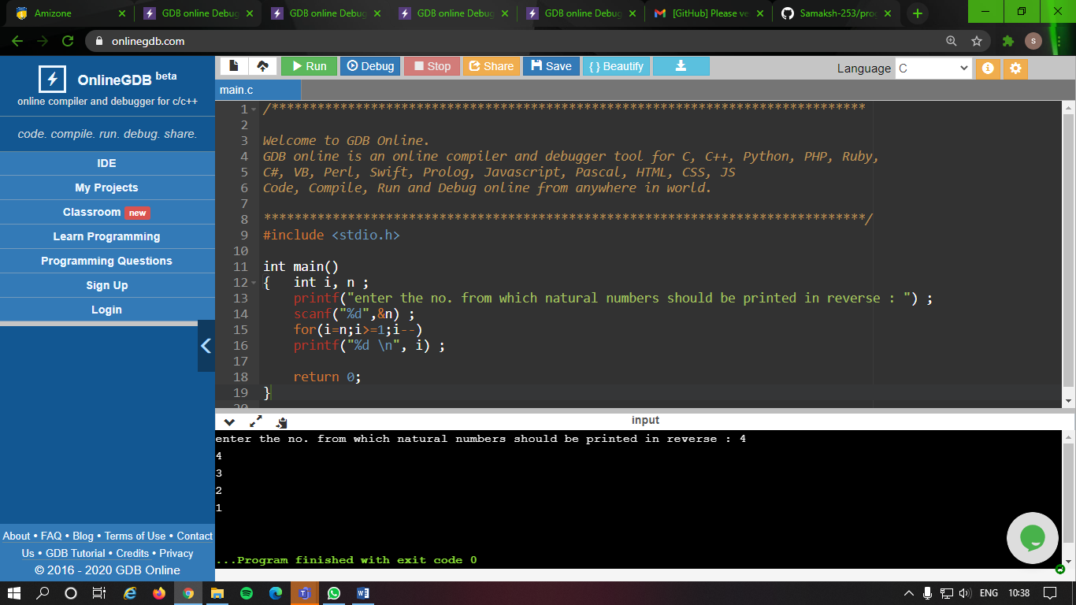

1. **CODE-**

#include <stdio.h>

int main()

{ char c ;

printf("Series to print all alphabets from a to z : \n") ;

for(c='a'; c<='z'; c++)

printf("%c,", c);

return 0;

}

**OUTPUT-**

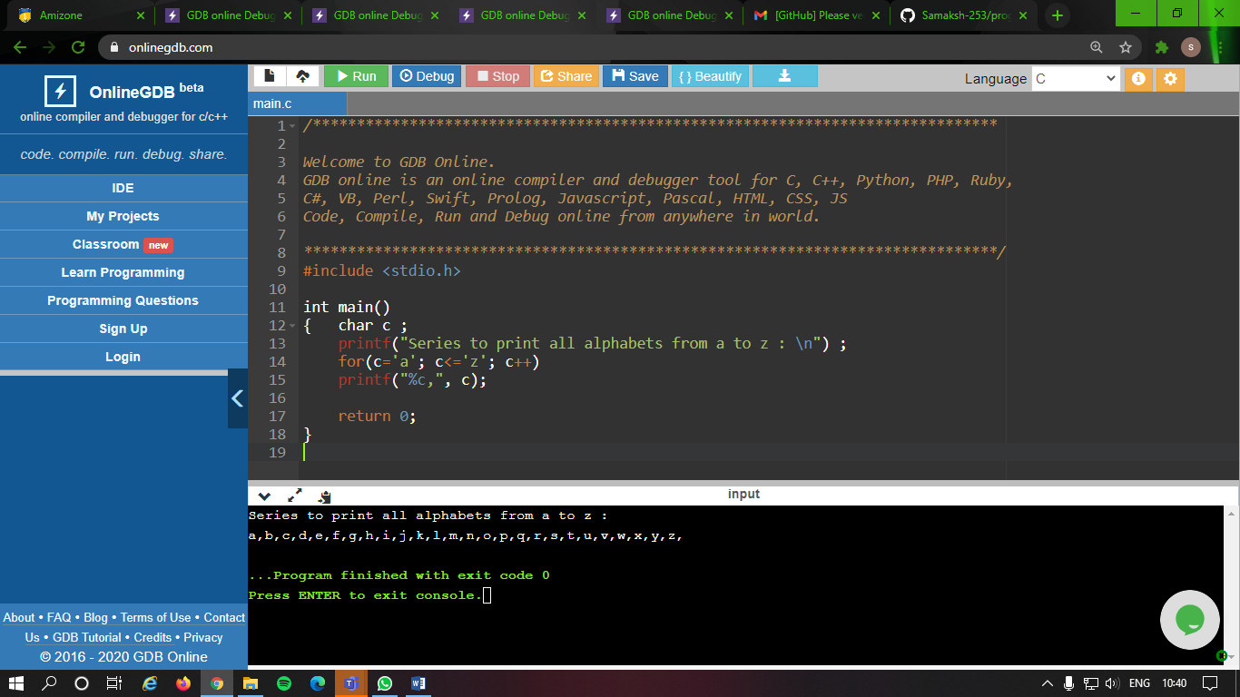

1. **CODE-**

#include <stdio.h>

int main()

{ int i ;

printf("Even numbers between 1 and 100 : \n") ;

for(i=1; i<=100 ;i++)

{ if(i%2==0)

printf("%d," ,i);

}

return 0;

}

**OUTPUT-**

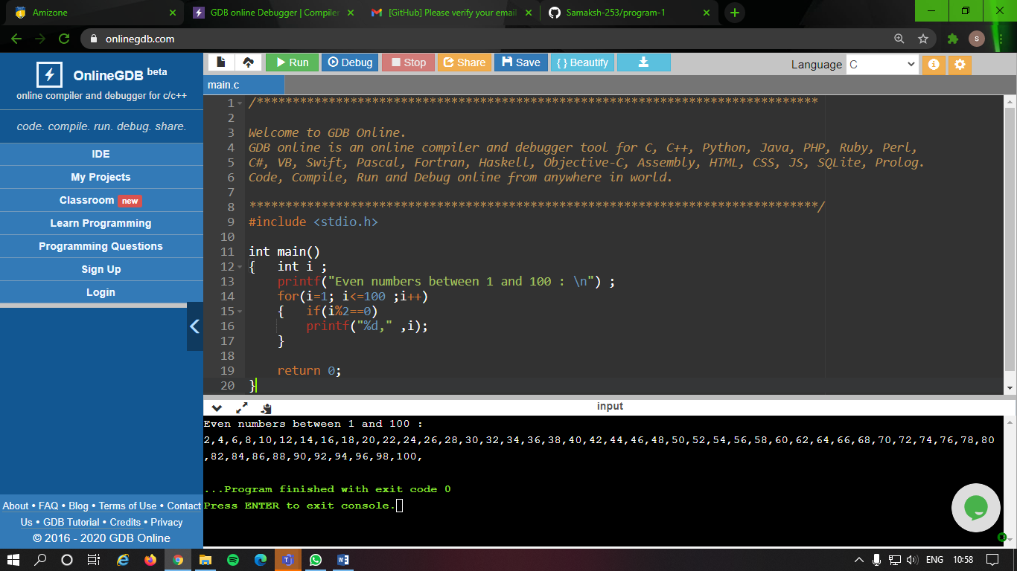

1. **CODE-**

#include <stdio.h>

int main()

{ int i ;

printf("Odd numbers between 1 and 100 : \n") ;

for(i=1; i<=100 ;i++)

{ if(i%2!=0)

printf("%d," ,i);

}

return 0;

}

**OUTPUT-**

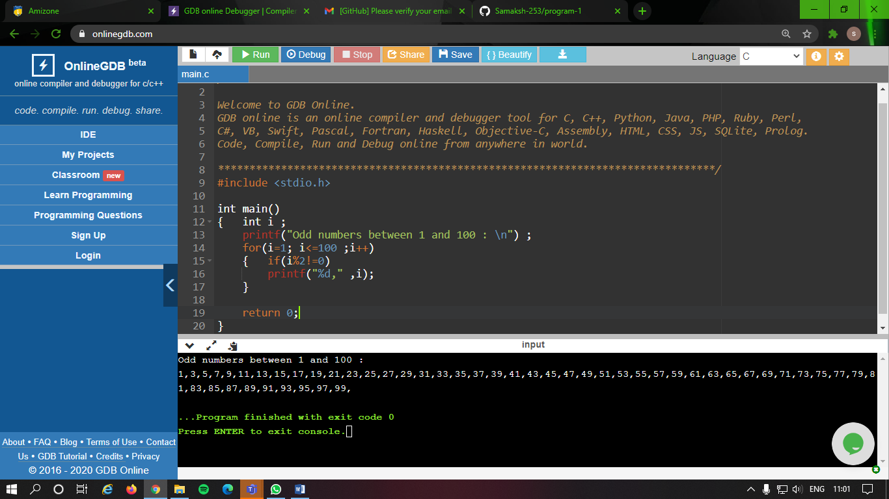

1. **CODE-**

#include <stdio.h>

int main()

{ int i, n, sum ;

printf("Enter the no. upto which sum must be found : ") ;

scanf("%d", &n) ;

for(i=1; i<=n; i++)

sum+=i ;

printf("%d \n", sum) ;

return 0;

}

**OUTPUT-**

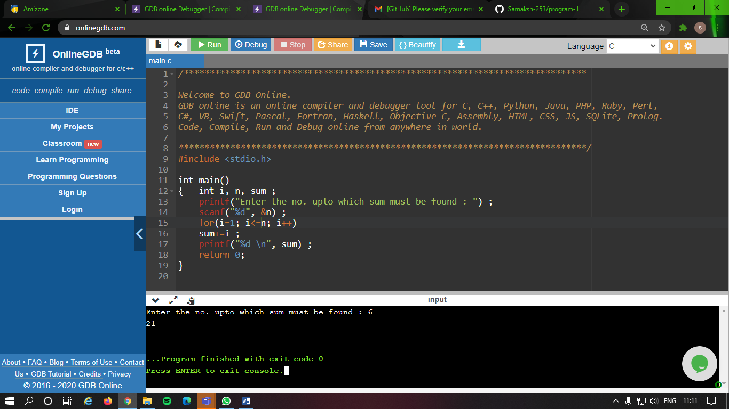

1. **CODE-**

#include <stdio.h>

int main()

{ int i, n, sum ;

printf("Enter the no. upto which sum of even nos. must be found : ") ;

scanf("%d", &n) ;

for(i=1; i<=n; i++)

{ if(i%2==0)

sum+=i ;

}

printf("%d \n", sum) ;

return 0;

}

**OUTPUT-**

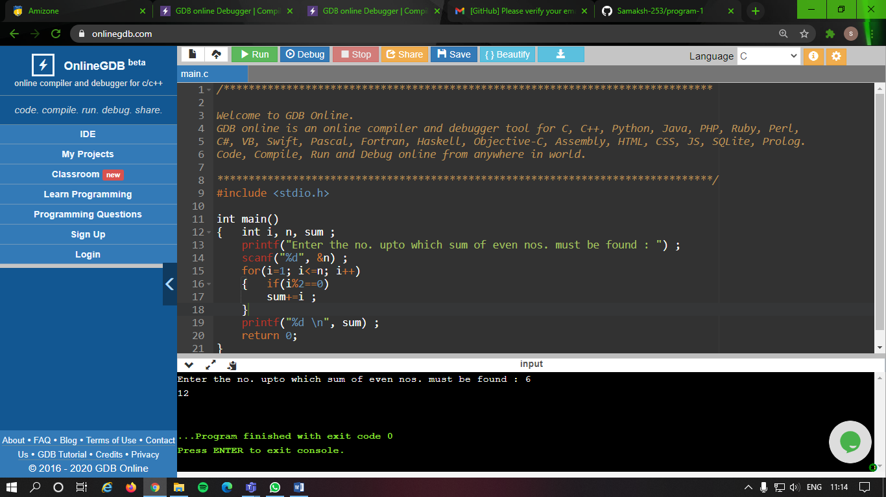

1. **CODE-**

#include <stdio.h>

int main()

{ int i, n, sum ;

printf("Enter the no. upto which sum of odd nos. must be found : ") ;

scanf("%d", &n) ;

for(i=1; i<=n; i++)

{ if(i%2!=0)

sum+=i ;

}

printf("%d \n", sum) ;

return 0;

}

**OUTPUT-**

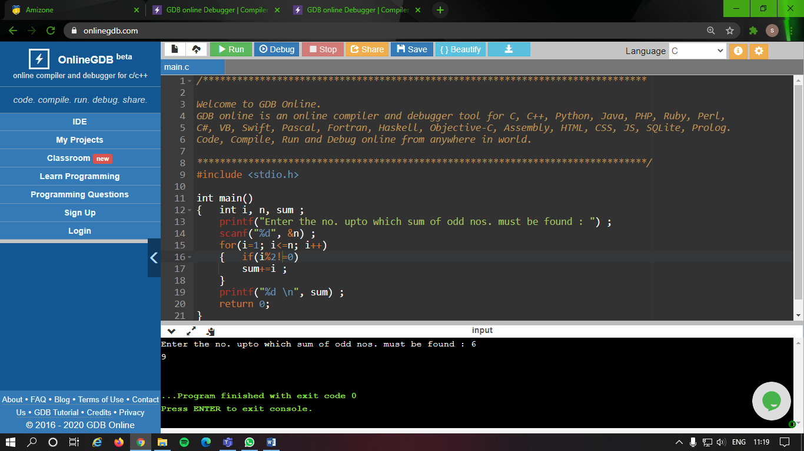

1. **CODE**-